SDA Designed for Mass Appeal
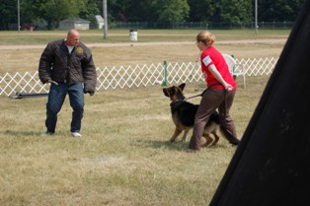

Hello, one of the main goals of SDA was to provide a working dog organization that has mass appeal to a wide variety of dog trainers and the ability to provide dog/handler teams from different dog sport organizations the capability to participate. SDA was designed to gives dog owners many options and choices while maintaining a very strict structure that is uniform for all participants. SDA Ultimate Dog sport was created by selecting some of the best protection exercises from different Dog Sports and by creating exercises that were needed and that are now identified as original to SDA. Most important, all titles were designed to meet the needs, interest, and lifestyles of most American dog owners that have a need for obedience, protection of all types, tracking and detection. Every title was carefully designed to require training exercises that meet the objectives of the title. SDA offers foundation titles, titles for identifying and testing dogs for professional needs, titles that test handler’s skills and offer competition and titles that test for working characteristics a dog may possess that may identify a dog as good stud dog or breeding female.
SDA obedience titles are some of the best in dog training and many of the exercises are very familiar to many trainers due to the similarity to Schutzhund obedience. SDA founders liked the structure of Schutzhund and the ability of many of the exercises to test the trainability of both the dog and handler; however SDA founders thought there was a lot room for improving Schutzhund style obedience titles. We at SDA considered the Schutzhund BH as being too difficult for beginners and the title lacked practical obedience exercises that are necessary for a Family companion dog. The SDA Family Obedience title requires both practical obedience exercises and traditional exercises. This title is perfect for introducing new people to dog training, creating business for dog trainers, creates demand for dog clubs and is a title that helps support dog trials.
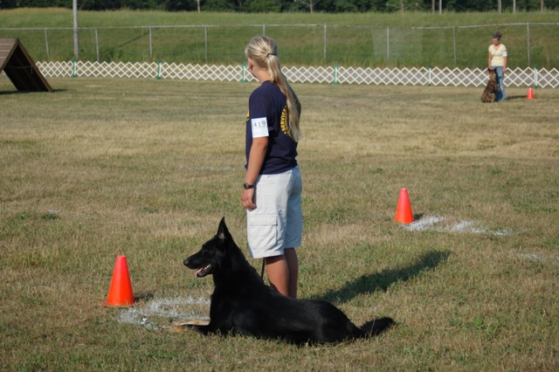
Other improvements with SDA obedience are when two dog handler teams are reporting and performing the long down; dogs are never off leash when reporting or performing a long down; this prevents dog fights and improves safety for all participants. Most dog fights occur in Schutzhund when reporting and when the dog has been left un- attended during the long down exercise. Preventing dog fights and preventing bad bites are more controllable when dogs are on leash in these exercises.
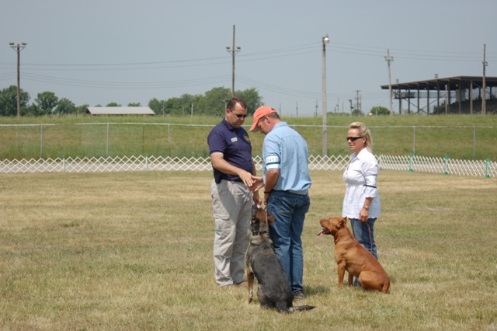
Other major improvements to SDA obedience over some Schutzhund titles is that the heeling pattern is only performed once with all titles and after a dog/handler team earn a Family Obedience title, handlers have the option of performing most of the exercises off leash; SDA P1, P1S & PD1 are designed for on leash heeling but handlers can perform off leash heeling as an option. Other improvements concern the sit out motion exercise; after the sit handlers go approximately between 10 and 15 paces past the dog and then turn and face the dog; this makes the exercises faster and more appealing, the next improvement concerns the recall; when the dog reports from the down; handlers have the option of performing a front and finish or straight to the side finish; this option allows dogs from different training programs to compete without conforming to one specific method.
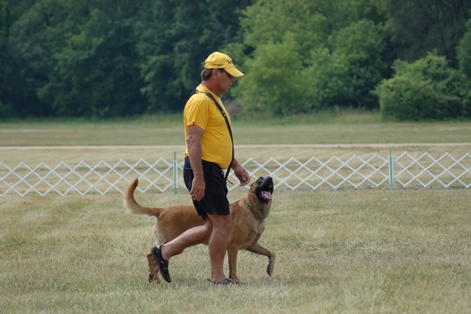
Next, concerns one of SDA ‘most proud contributions to dog training which is the Agility Recall exercise; this exercises is performed after the recall and the dog is heeled to a starting point where it is left in a sit five yards from an incline wall while the handler continues up field to a location approximately 15 paces in front of the last obstacle a dog must jump. On the judge’s instructions the dog is called and starts climbing and jumping over a series of obstacles such a incline wall ,window jump, rail jump, and a solid jump; then when the dog jumps the last obstacle the dog is commanded to down and then a recall and finish.
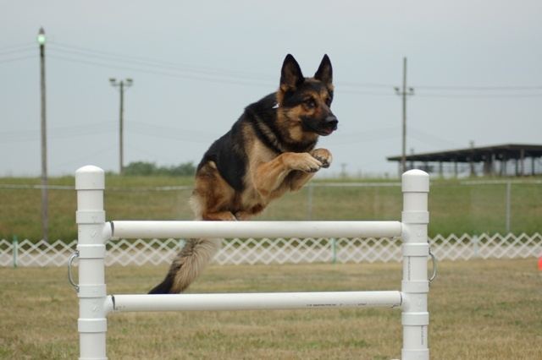
The Agility Recall is one of most entertaining and challenging exercises to be developed by SDA concerning obedience. SDA created this exercises to test the athletic ability of a dog, to incorperate agility into our advanced obedience routines and to replace the many retrieves that are required for Schutzhund. SDA requires only one retrieve in some of its advanced titles. Schutzhund requires three retrieves and they count for 45 points of an obedience performance; we at SDA consider this many points for retrieving during obedience to be excessive. In addition, SDA evaluates a dog’s retrieving score by basing more points on the dog’s desire, speed going and coming and its attitude for retrieving. Last, SDA retained the Send Out exercise and only requires it for our P3 & PS3 titles; Police titles and our Personal or Family Protection titles do not require any retrieving. We at SDA believe that we have taken Schutzhund type obedience and improved it tremendously by making it more fun to watch and enjoyable to train.
SDA Protection Program is super and has mass appeal; first, SDA protection program is designed with the same concepts as the new Human sport of Mixed Martial Arts or the UFC. The goals of the SDA founders were to create a protection dog sport that offers protection training titles that are realistic, titles that can be performed by wide variety of dog trainers and dogs, protection titles that are as real as possible for meeting the needs of Family or personal protection dogs, police dogs, and titles that offer competition and test breed worthiness while providing a safe environment and conditions for both handlers, dogs and other participants.
We at SDA believe we have accomplished the above goals and especially when our decoys are performing correctly during a trial and they are able to cause the dog to view the decoy as an adversary and not just a gripping partner; SDA decoys use body posturing, direct eye contact, intimidating confrontation driving and a hostile mannerism to challenge the dog. SDA is the only protection dog organization in the world that encourages its decoys to use adversarial mannerism while performing protection exercises. I will provide some pictures with this article that demonstrate the decoys actions and mannerisms for being adversarial.
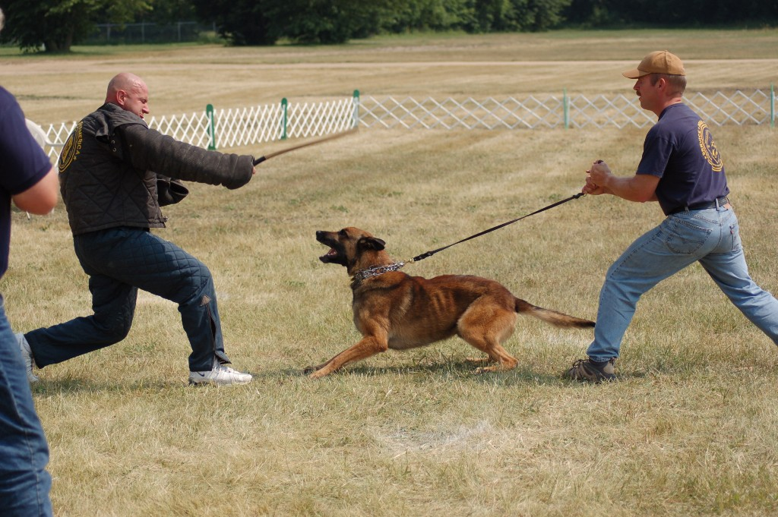
Another major reason SDA protection program has mass appeal is because SDA allows leg biting, targeted arm grips, inner arm grips on certain exercises and offers a very safe long attack that is challenging and entertaining to watch. In addition, SDA also offers three sleeve titles called P1S, P2S & P3S The SDA P3S is protection routine that is identical to current Schutzhund 3 protection routine except that decoys can yell, stick strikes can come at any time were required, decoy use intimidating body postures and eye contact when challenging and driving the dog. SDA P2S & S are basically Schutzhund without the requirement of tracking and these titles offer Schutzhund trainers another venue for competing with their dog. The obedience is so similar that most dogs will adjust very fast.
Last and most appealing about SDA protection program is the ability of each club and handler to pursue the type of training they prefer; a handler can train his dog to be as real as possible with multiple gripping areas or a handler may train his dog for a more sporty attitude. SDA protection program has flexibility to meet the needs of a personal protection dog, police service dogs and dogs for high level competition that have more sporty nature. No matter what path a dog/handler team takes; SDA decoys will work the dog in an adversarial manner that makes the protection as realistic as possible.
In closing, we at SDA named our dog sport, SDA Ultimate Dog Sport, and we feel that our program can live up to its name. If this article and our website create an interest please get involved. We at SDA share a dream of making this program into one of the best in the world. SDA was created here in the US and we at SDA think it’s time that a US Dog Sport makes a major contribution to improving true working dogs that perform a service! SDA welcome all breeds and all dog loving responsible people!
The following pictures demonstrate adversarial mannerism that SDA Helpers are encouraged to use while working the dog. The main major difference between SDA Protection program versus all other dog sport programs is that dog must be able to work against a helper that is doing his best to make the dog view the helper as true adversary and not just his gripping partner; most sport dog programs the dog really doesn’t feel threaten and is totally performing its protection with prey drive!
